The Pomodoro Technique [1]

# What is the Pomodoro Technique?

Pomodoro is a technique for increasing productivity and focus by getting yourself into a state a Flow.

Basic requirements

|  |  |  |
| --- | --- | --- |
| **① A kitchen timer** | **② A short to-do list [2]** | **③ A little discipline [2]** |
|  |  | • Turn off Phone(s)  • Turn off IMs or DND  • No non-task related browsing  • No bathroom breaks*  • No conversations  • No meetings  • No eating  • No preening |

# How does it work?

1. Choose a task you’d like to get done

2. Set the Pomodoro for 25 minutes

3. Work on the task until the Pomodoro rings

4. When the Pomodoro rings, put a checkmark on a paper

5. Take a short break

6. Every 4 Pomodoros, take a longer break

# What does this buy me?

1. Find out how much effort an activity requires you by monitoring how many Pomodoros you need in order to accomplish a specific task

2. Learn to protect your Pomodoro from the internal and external interruption

3. Make accurate estimations of how many Pomodoros you need for a certain activity

4. Set a timetable according to your to-dos, to your time, or even to the season

# Why does this work? (Theory)

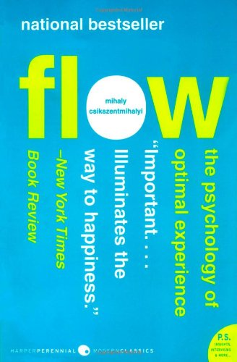*Flow: The Psychology of Optimal Experience* by Mihaly Csikszentmihalyi [3]

### From Amazon.com

Psychologist Mihaly Csikszentmihalyi's famous investigations of "optimal experience" have revealed that what makes an experience genuinely satisfying is a state of consciousness called *flow*. **During flow, people typically experience deep enjoyment, creativity, and a total involvement with life**. In this new edition of his groundbreaking classic work, Csikszentmihalyi demonstrates **the ways this positive state can be controlled, not just left to chance.** *Flow: The Psychology of Optimal Experience* teaches how, **by ordering the information that enters our consciousness, we can discover true happiness and greatly improve the quality of our lives.**

### From Library Journal

Aristotle observed 2300 years ago that more than anything men and women seek happiness. Csikszentmihalyi (psychology, Univ. of Chicago) has for 25 years made similar observations regarding "flow," a field of behavioral science examining connections between satisfaction and daily activities. **A flow state ensues when one is engaged in self-controlled, goal-related, meaningful actions.** Data regarding flow were collected on thousands of individuals, from mountain climbers to chess players. **This thoroughly researched study is an intriguing look at the age-old problem of the pursuit of happiness and how, through conscious effort, we may more easily attain it**. Recommended for general readers.  
*- Terry McMaster, Utica Coll. of Syracuse Univ. Lib., N.Y .*

# Attributions and References

[1] The Pomodoro Technique, <http://pomodorotechnique.com/>

[2] Personal Productivity Using The Pomodoro Technique, Daniel Hinojosa, <https://docs.google.com/presentation/d/1ufjcILARuowbv3Y9r-FP9-x3kmlIzq7bvOJBxRVh3-w/present#slide=id.i0>

[3] Flow: The Psychology of Optimal Experience, Mihaly Csikszentmihalyi, <http://www.amazon.com/Flow-Psychology-Experience-Mihaly-Csikszentmihalyi/dp/0061339202/>

# Walkthrough

To Do Today

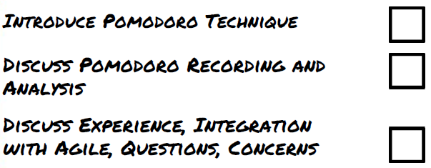

Underestimated

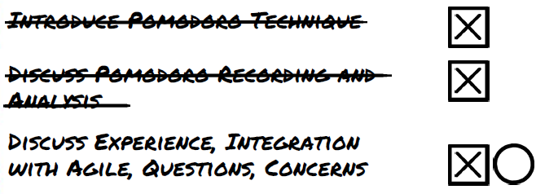

Unplanned Interruptions (Internal and External)



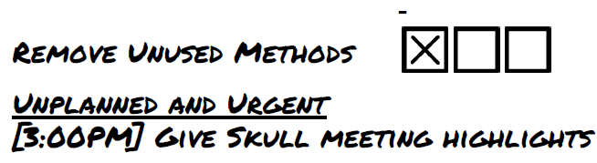

Record Sheet

